**PRESIDENCY COLLEGE**

Re-accredited NAAC ‘A+’ and NIRF Ranked College 33/2C & 33/2D,Kempapura,Hebbal,Bangalore-560024

**VISUAL PROGRAMMING ASSIGNMENT**

**NAME**:- Podili Avinash Rao

**REG NO**:- 17YASB7079

**COURSE**:- BCA 4th SEM

**SECTION**:- ‘B’

1. Create an application simple calculator which can perform addition, subtraction, multiplication and division.

GUI:

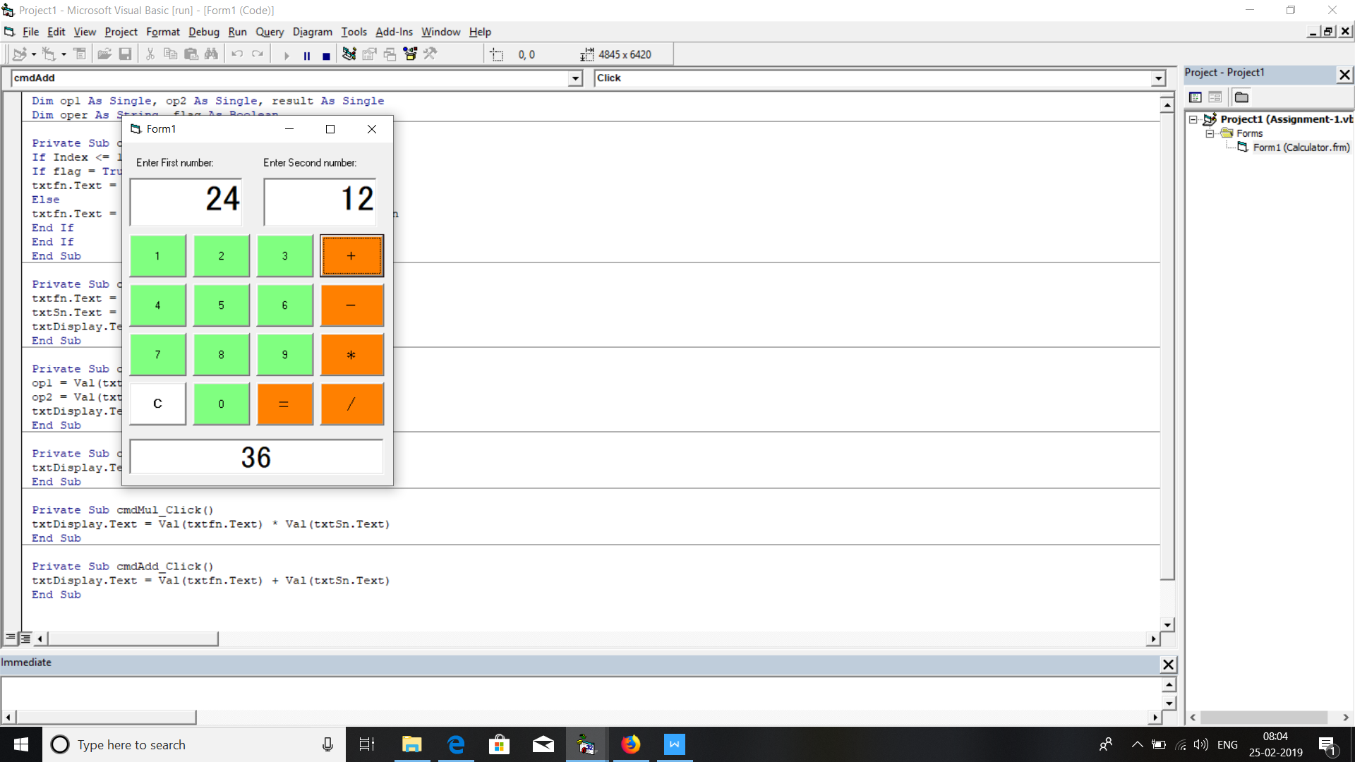

Code:

Dim op1 As Single, op2 As Single, result As Single

Dim oper As String, flag As Boolean

Private Sub cmdnum_Click(Index As Integer)

If Index <= 10 Then

If flag = True Then

txtfn.Text = cmdnum(Index).Caption

Else

txtfn.Text = txtDisplay.Text & cmdnum(Index).Caption

End If

End If

End Sub

Private Sub cmdReset_Click()

txtfn.Text = ""

txtSn.Text = ""

txtDisplay.Text = ""

End Sub

Private Sub cmdsub_Click()

op1 = Val(txtfn.Text)

op2 = Val(txtSn.Text)

txtDisplay.Text = op1 - op2

End Sub

Private Sub cmdDiv_Click()

txtDisplay.Text = Val(txtfn.Text) / Val(txtSn.Text)

End Sub

Private Sub cmdMul_Click()

txtDisplay.Text = Val(txtfn.Text) * Val(txtSn.Text)

End Sub

Private Sub cmdAdd_Click()

txtDisplay.Text = Val(txtfn.Text) + Val(txtSn.Text)

End Sub

1. Create a simple stop watch by using timer control.

GUI:

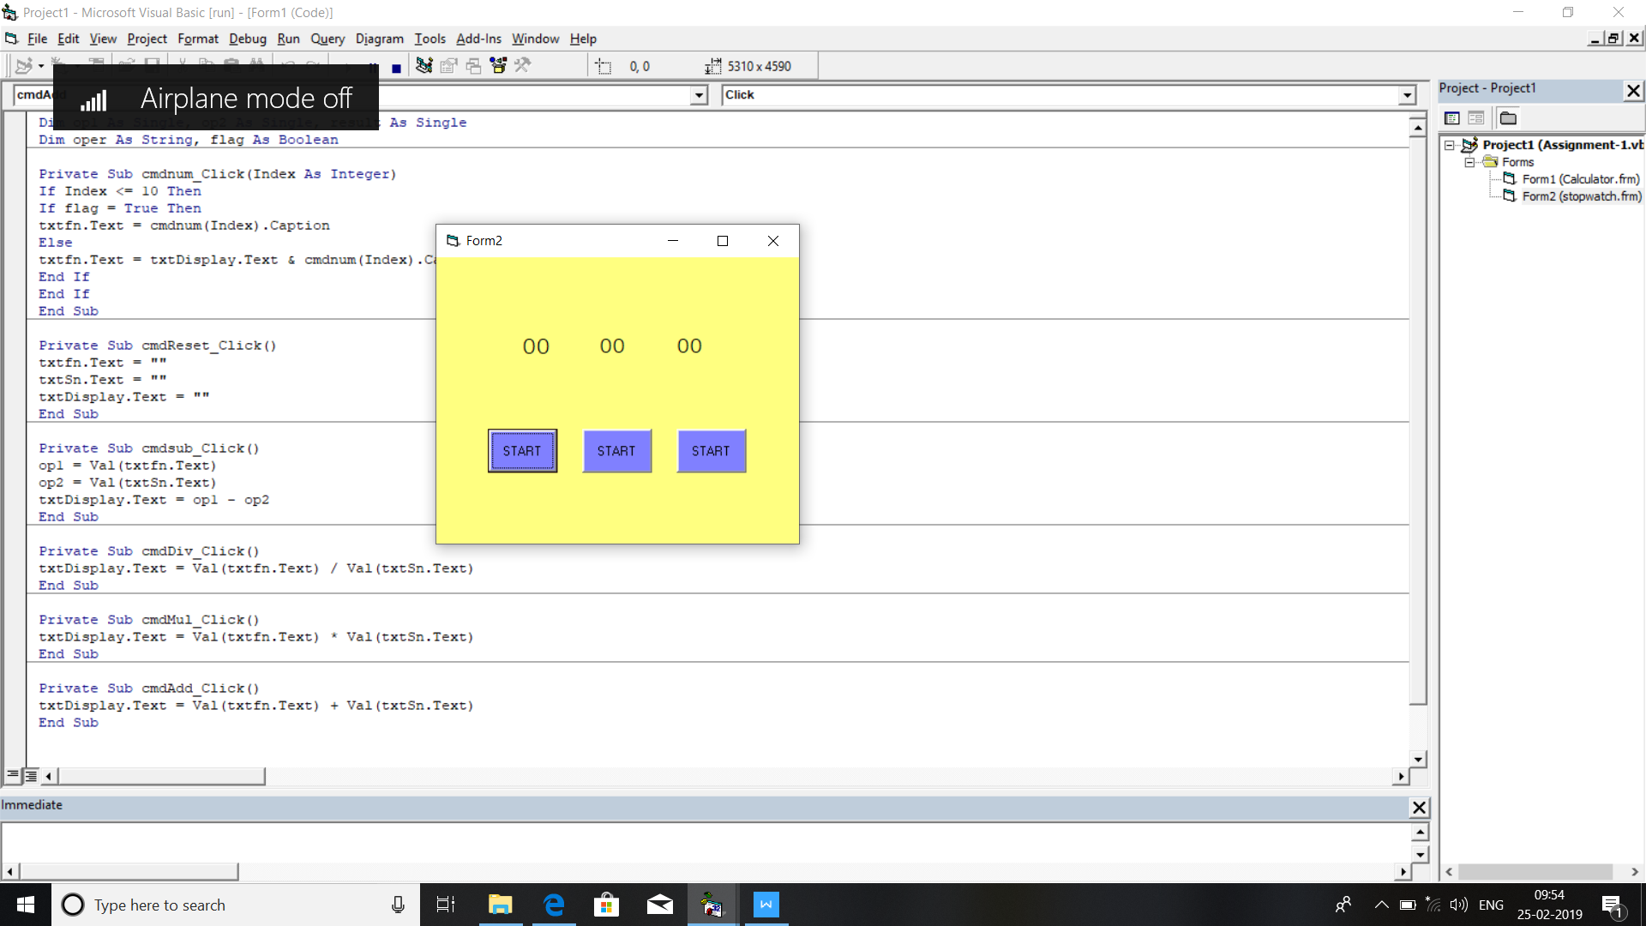

CODE: Stopwatch

Private Sub cmdres_Click()

Timer1.Enabled = False

Label1.Caption = "00"

Label2.Caption = "00"

Label3.Caption = "00"

End Sub

Private Sub cmdstart_Click()

Timer1.Enabled = True

End Sub

Private Sub cmdstop_Click()

Timer1.Enabled = False

End Sub

Private Sub Timer1_Timer()

Label3.Caption = Val(Label3.Caption) + 1

If Label3.Caption = 10 Then

Label3.Caption = 0

Label2.Caption = Val(Label2.Caption) + 1

End If

If Label2.Caption = 60 Then

Label2.Caption = 0

Label1.Caption = Val(Label1.Caption) + 1

End If

End Sub

1. Write all the validations for the following consideration for textbox.

GUI:

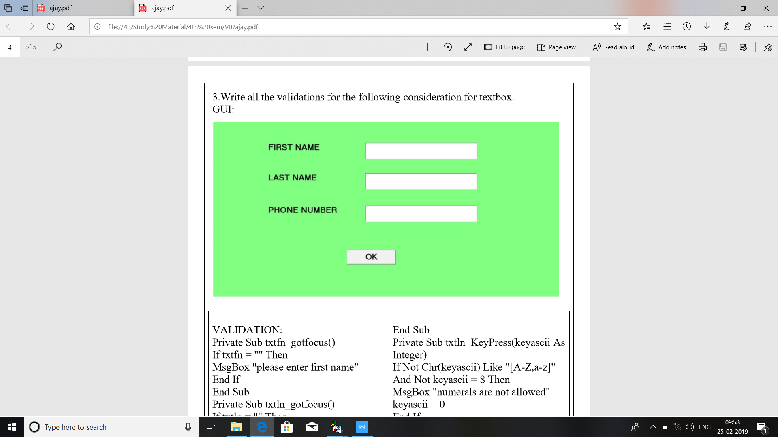

‘VALIDATION:

Private Sub txtfn_gotfocus()

If txtfn = "" Then

MsgBox "please enter first name"

End If

End Sub

Private Sub txtln_gotfocus()

If txtln = "" Then

MsgBox "please enter last name"

End If

End Sub

Private Sub txtpn_gotfocus()

MsgBox "please enter your phone number"

End Sub

Private Sub txtfn_KeyPress(keyascii As Integer)

If Not Chr(keyascii) Like "[A-Z,a-z]" And Not keyascii = 8 Then

MsgBox "numerals are not allowed"

keyascii = 0

End If

End Sub

Private Sub txtln_KeyPress(keyascii As Integer)

If Not Chr(keyascii) Like "[A-Z,a-z]" And Not keyascii = 8 Then

MsgBox "numerals are not allowed"

keyascii = 0

End If

End Sub

Private Sub txtpn_keypress(keyascii As Integer)

If Not Chr(keyascii) Like "[0-9]" And Not keyascii = 8 Then

MsgBox "only numerals are allowed"

keyascii = 0

End If

End Sub

1. Design an application to record student details such as student name,student id,semester and college.Display different subjects for that class on selection of semester.use select case for decision making.

GUI:

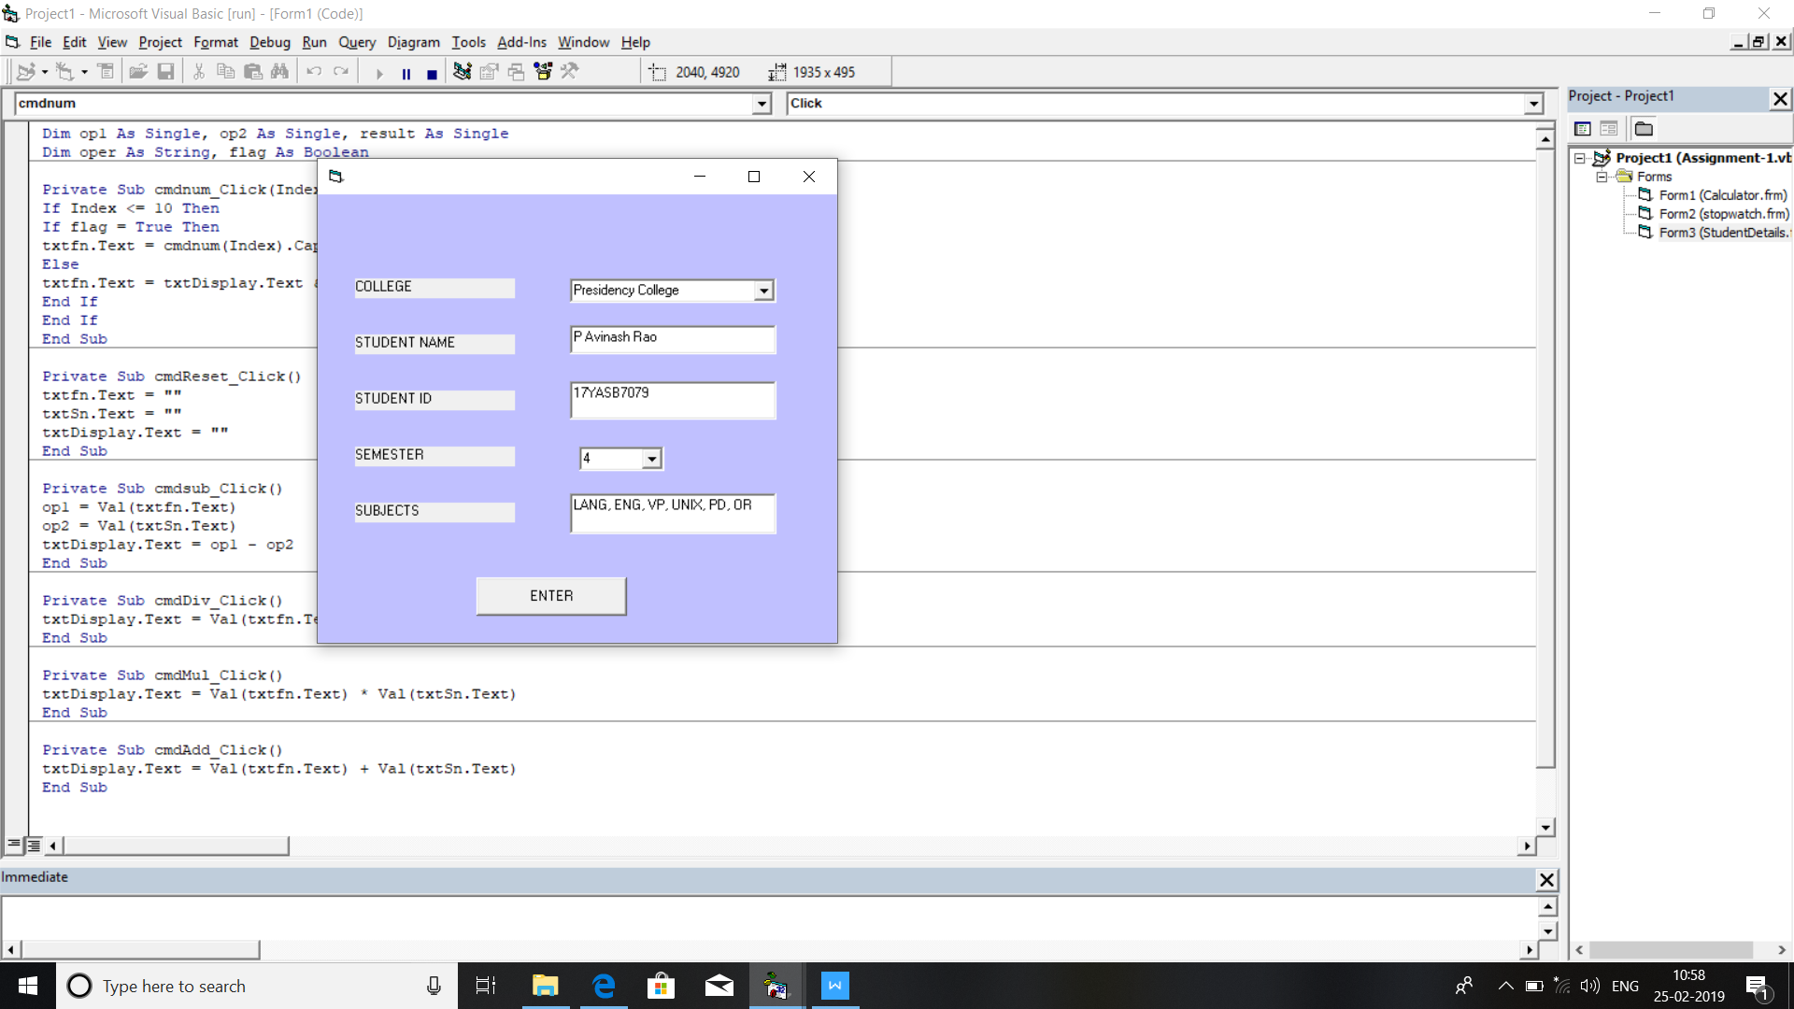

Code: Student Details

Private Sub cmd_Click()

Select Case sem

Case 1

txtsub = "LANG, ENG, DM, C, DE, EPH."

Case 2

txtsub = "LANG, ENG, NM, DS, DBMS, IC."

Case 3

txtsub = "LANG, ENG, AFM, OS, C++, CDS."

Case 4

txtsub = "LANG, ENG, VP, UNIX, PD, OR."

Case 5

txtsub = "JAVA, SE, MP, CA, B&F, DCN."

Case 6

txtsub = "TOC, CR, WP, SP, EN."

Case Else

txtsub = "INVALID!"

End Select

End Sub

Private Sub txtsn_KeyPress(KeyAscii As Integer)

If Not Chr(KeyAscii) Like "[A-Z,., ,az]" And Not KeyAscii = 8 Then

MsgBox "numerals are not allowed"

KeyAscii = 0

End If

End Sub